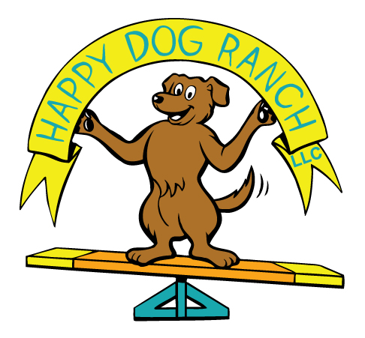  UPdog Challenge  October 20 & 21, 2018  Happy Dog Ranch, LLC  2809 Bearwallow Road  Ashland City, TN 37015  How Do I Sign Up?  - Complete the entry form below or go to our web site at: www.happydogranchtn.com/events to register online.  - To track your points, you can sign up as a Team through the Updog Challenge web site. https://updogchallenge.com/  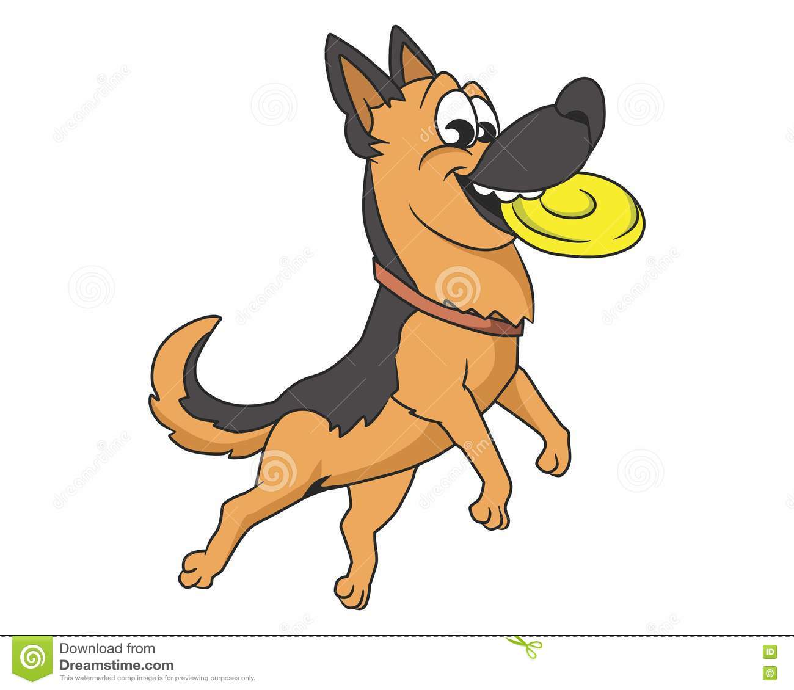  - You do not have to be registered to enter, but if you want to earn titles, you need to register your dog.  Start Time?  Day-Of Entries: 8:00am Pre-Entry: 8:30am  We will start the first briefing at 8:30am  How Much Does It Cost?  Mailed In Entries: If your paper entry form and check are postmarked on or prior to July 13th, The fee is $10.00 per run.  Online Entries: If you register for the trial online, the fee is $10.00 per run.  Day-Of entries: If you do not per enter the trial, the fee is 12.00 per run.  Contact  Email: happydogkn@gmail.com  Phone: (615) 792-1289  Text: (805) 509-2445. | Classes Offered  Saturday:  Throw-n-Go  4 Way Play  Funkey  7 Up  Sunday:  Time Warp  Spaced Out  Frizgility  2 runs in each class!!  Enter Online at:  Happydogranchtn.com under the events page  Or  Complete this entry form and mail to:  Happy Dog Ranch, LLC  2809 Bearwallow Road  Ashland City, TN 37015

Notice to Participants
It is expressly understood that participants alone are responsible for the behavior of their dogs and/or children. Any participant whose dog and/or children create an unnecessary disturbance or repeatedly engage in unsafe or disruptive behavior may, at the discretion of the event committee, be asked to leave the event site. In such case, no refund of any fees paid will be made. Happy Dog Ranch, LLC and its agents, employees, etc., will assume no responsibilities for any loss, damage, or injury sustained by participants or spectators, or to any of their dogs or property and further assumes no responsibility for injury to children.
Happy Dog Ranch, LLC reserves the right to decline entries for cause and may remove any dog because dog or human aggression. No one shall have any recourse or claim against Happy Dog Ranch, LLC or any official thereof.
This is a NON-SMOKING FACILITY.
Exhibitor Information
Please pick up after your dog and dispose of waste in appropriate containers outside the building. When not competing, dogs must be under control at all times.
Ring Location: The ring will be located on our 13-acre property. The property is partially fenced.
Safety: At all times, the safety of the dogs and handlers is to be of paramount importance.
Crating: Exhibitors may crate from their cars or crating on the grass. You may also set up crates in the hallway of our dog boarding kennel which is air conditioned. Some crating will be allowed in the air-conditioned straw room once the Barn Hunt Association trial is over for the day.
Leashes and Collars: Prong, choke, electronic, and Flexi-leads are forbidden on the show grounds. Martingale collars, slip leads, head collars and buckle collars are allowed.
Bitches in season: Are allowed to compete but must wear panties.
Refunds: No event fee will be refunded if the event cannot open or be completed by reason of riots, civil disturbances, fire, and act of God, public emergency, act of a public enemy, or any other cause beyond the control of the event committee. Entry fees will not be refunded in the event that a dog is absent, disqualified, sick, excused, or barred from competition by action of the Event Committee.
Food Services: There are limited fast food restaurants within driving distance from the event location. We will provide lunch for anyone who works or charge $5.00 for non-workers.
Overnight Accommodations
RV’s/Trailers: There is a $15.00 fee for RV’s, Trailers or overnight vehicles. There are no hookups but plenty of parking space on the farm. Not tent camping in the straw room due to the BHA trial.

Hotels
Day’s Inn – Joelton
201 Gifford Place, Joelton, TN 37080 1-866-678-6350

Super 8 Motel – Whites Creek/Nashville
7551 Old Hickory Blvd. Whites Creak, TN 1 -855-238-1592

Awards: Happy Dog Ranch will provide awards for 1st through 3rd in the first round of each game. Heights will be combined for placements.
Volunteers: Volunteers are always helpful and appreciated. We will provide lunch and drinks to workers.
DIRECTIONS
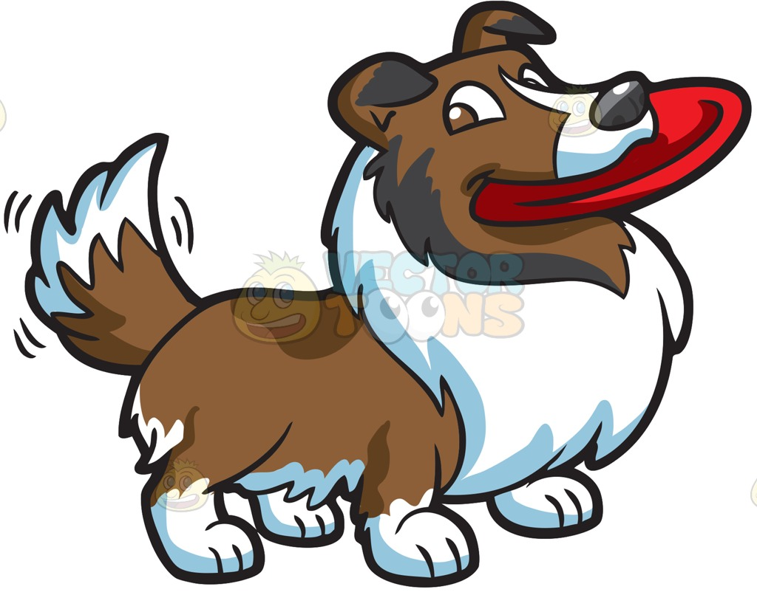
From Nashville:
* Take I-24 West, head towards Clarksville (13 miles)
* Exit at New Hope Road – Exit 31
* At the end of the ramp, turn Left onto New Hope Road (TN-249)
* Go through the stoplight, drive about 1.5 miles, turn Right at the flashing
light onto Old Clarksville Pike (TN-249)
* Drive about a mile, turn Left onto Bearwallow Road (TN-249) (Todd's
Automotive and Dollar General on the corners)
* Follow Bearwallow Road for 1.4 miles.
* We no longer have a business sign!! Turn at our mailbox, at 2809 Bearwallow Road.
* Take the driveway through the woods and along the pastures to our
property. Really, we are easy to find.
From Clarksville:
* Take I-24 East, head towards Nashville (20 miles)
* Exit at New Hope Road – Exit 31
* At the end of the ramp, turn Right onto New Hope Road (TN-249)
* Go through the stoplight, drive about 1.5 miles, turn Right at the flashing
light onto Old Clarksville Pike (TN-249)
* Drive about a mile, turn Left onto Bearwallow Road (TN-249) (Todd’s
Automotive and Dollar General on the corners)
* Follow Bearwallow Road for 1.4 miles.
* We no longer have a business sign!! Turn at our mailbox, at 2809 Bearwallow Road.
* Take the driveway through the woods and along the pastures to our
property. Really, we are easy to find.

GPS NOTICE! If you use GPS to find us, type in our address rather than our business name. GPS has the incorrect address under our business and it will take you to the wrong driveway! The Correct Address is: 2809 Bearwallow Road, Ashland City, TN 37015

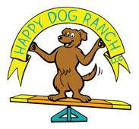
ENTRY FORM
Happy Dog Ranch, LLC
UpDog Games Challenge
October 20 & 21, 2018
Make checks payable to: Happy Dog Ranch
Mail to: Happy Dog Ranch, 2809 Bearwallow Road, Ashland City, TN 37015

UpDog Team Number: |  | Owner’s Name
Dog’s Name: |  | Handler Name (If different)
Dog’s Registered Name:  Male ________ Female _________ |  | Mailing Address  Street:
Mailing Address
City/Zip Code:

Breed: |  | Phone:
Date of Birth: |  | Email (Required):
Dog’s Height Division: | Mini (13” and under) | Midi (13.1” to 17”) | Maxi (Over 17”)
Owners are responsible for entry errors. Please write clearly and proof your entry. Barn Hunt LLC will not make corrections once trial results are submitted.

Check the circle next to the class you are entering.

 | Round 1 | Round 2 | Total:  $10.00 each
SATURDAY
Throw N Go |  |  | $
4 Way Play |  |  | $
Funkey |  |  | $
7 Up |  |  | $
SUNDAY
Frizgility |  |  | $
Time Warp |  |  | $
Spaced Out |  |  | $
Total Entry: |  |  | $

Entries will not be considered complete without a completed Release Agreement Form.

RELEASE AGREEMENT FORM
Certification of Agreement upon Registration or Entry of Dog
I certify that I am the actual owner of the dog, or that I am the duly authorized agent of the actual owner whose name I have entered above. In consideration of the acceptance of this entry, I (we) agree to abide by the rules and regulations of UpDog Challenge in effect at the time of this event, and by any additional rules and regulations appearing in the premium list for this event, and further agree to be bound by the liability waiver enclosed with my entry. I (we) certify and represent that the dog entered is not a hazard (dog or human aggressive) to persons or other dogs. This entry is submitted for acceptance on the foregoing representation and Agreement. I (we) agree to conduct myself (ourselves) in accordance with all Updog Challenge Rules and Regulations and to abide by any decisions made in accord to them.

Liability Waiver
I (we) agree that Happy Dog Ranch, LLC has the right to refuse this entry for cause which the club shall deem sufficient. In consideration of the acceptance of this entry and of the holding of this event and of the opportunity to win prizes, ribbons, and/or trophies, I (we) agree to hold UpDog Challenge, Happy Dog Ranch, LLC, their members, directors, governors, officers, agents, or event secretary and the owner and/or lessor of the premises and any provider of services that are necessary to hold this event and any employees or volunteers of the aforementioned parties, and any UpDog Challenge approved judge, judging at this event, harmless from any claim for loss or injury which may be alleged to have been caused directly or indirectly to any person or thing by the act of this dog while in or about the event premises or grounds or near any entrance thereto, and I (we) personally assume all responsibility and liability for any such claim; and I (we) further agree to hold the aforementioned parties harmless from any claim for loss and expense (including legal fees) by reason of the liability imposed by law upon any of the aforementioned parties for damage because of bodily injuries, including death at any time resulting there from, sustained by any person or persons, including myself (ourselves), or on account of damage to property, arising out of or in consequence of my (our) participation in this event, however such, injuries, death or property damage may be caused, and whether or not the same may have been cause or may be alleged to have been caused by the negligence of the aforementioned parties or any of their employees, agents, or any other persons.

Media Release Form
I hereby authorize club-appointed videographer and/or photographer to use, reproduce, and/or publish photographs and/or video that may pertain to me, including my image, likeness and/or voice without compensation. I understand that this material may be used in various publications, public affairs releases, recruitment materials, the Happy Dog Ranch, LLC web site, yahoo group or Facebook page, or for related endeavors. This authorization is continuous and may only be withdrawn by my specific rescission of this authorization. Consequently, Happy Dog Ranch, LLC may publish materials, use my name, photograph, and/or make reference to me in any manner that the Corporation or project sponsor deems appropriate in order to promote/publicize service opportunities.
I have read the above. Signature of owner or his agent duly authorized to make this entry:

X __________________________________________________________________

