Creating an UpDog Account and an UpDog Team
Step 1:
Register your account
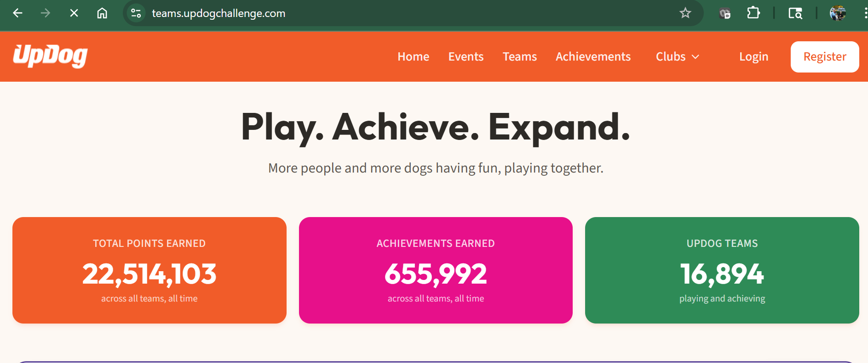

Choose an option to create an account:
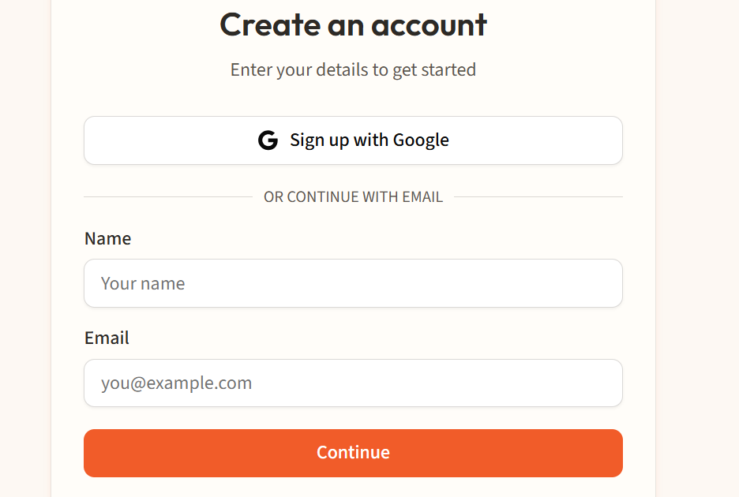
Step 2:
Create a Team
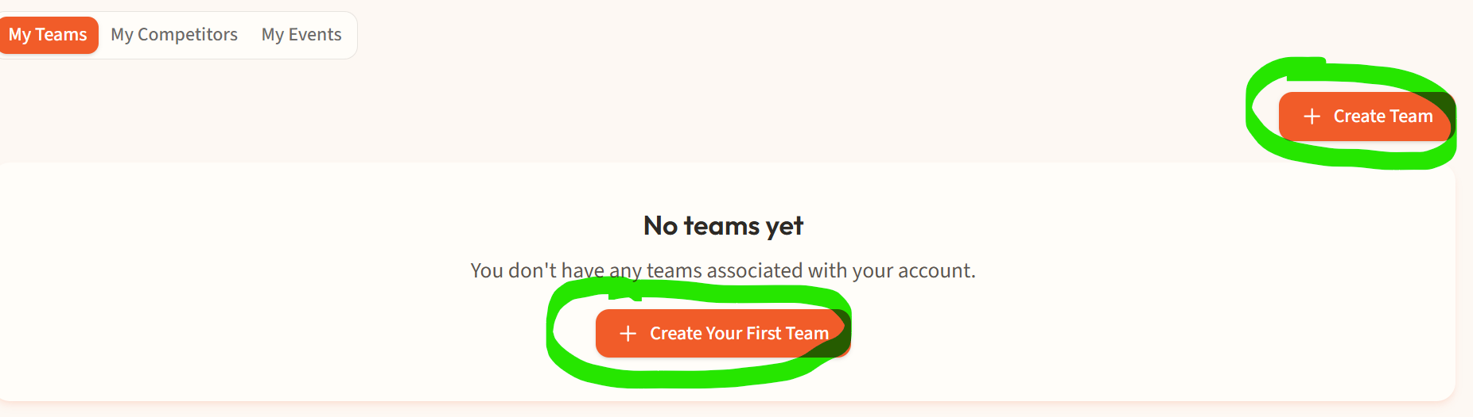
Choose which type of team you are creating. A Standard Team is 1 human and 1 dog. A Pairs Team is 2 humans and 1 dog – this team type is for playing Pairs games only.
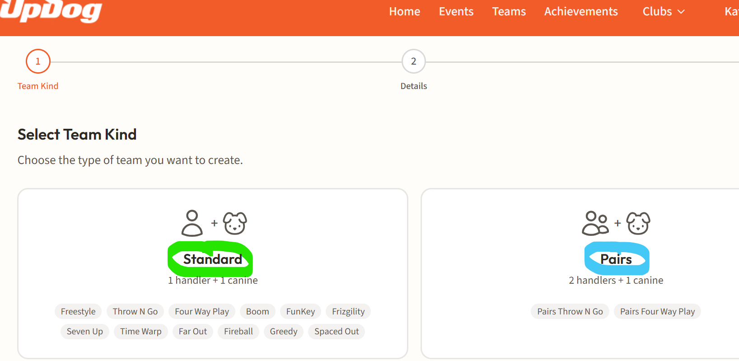
Creating a Standard Team:
Choose Standard and click Next

If the human member of the team already exists search for that human by typing their name in the box. If the human member of the team is new to UpDog click Create New Human.
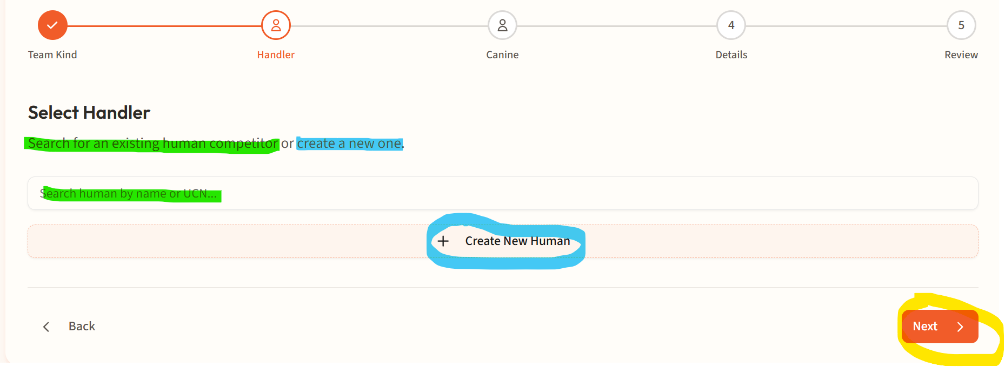

For this example, we are going to Create New Human. Enter the human’s full name, gender and birthdate and click Create Human. Then click Next.
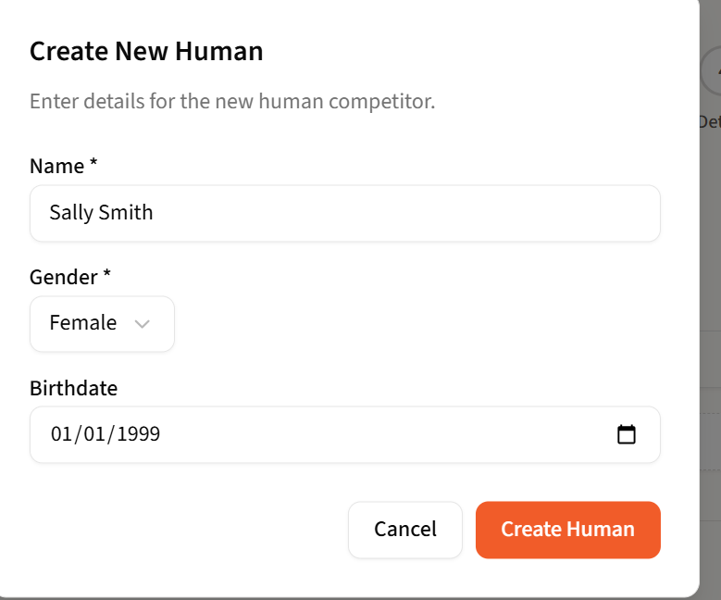

If the canine member of the team already exists search for that canine by typing their name in the box. If the canine member of the team is new to UpDog click Create New Canine.
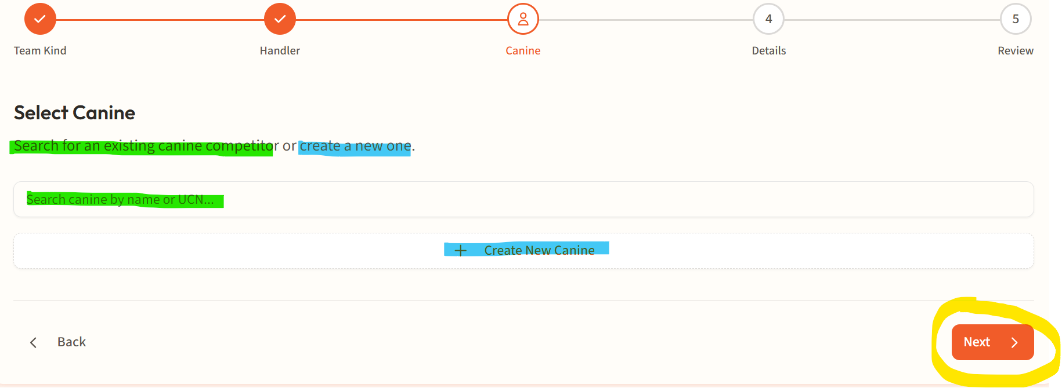
For this example, we are going to Create New Canine. Enter the dog’s name, gender, birthdate, height at withers, preferred jump height and click Create Canine. Then click Next.
Jump heights allowed by dog height at the withers:
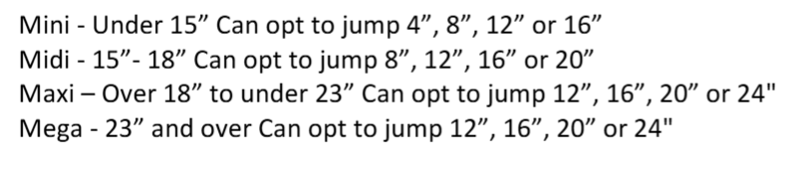
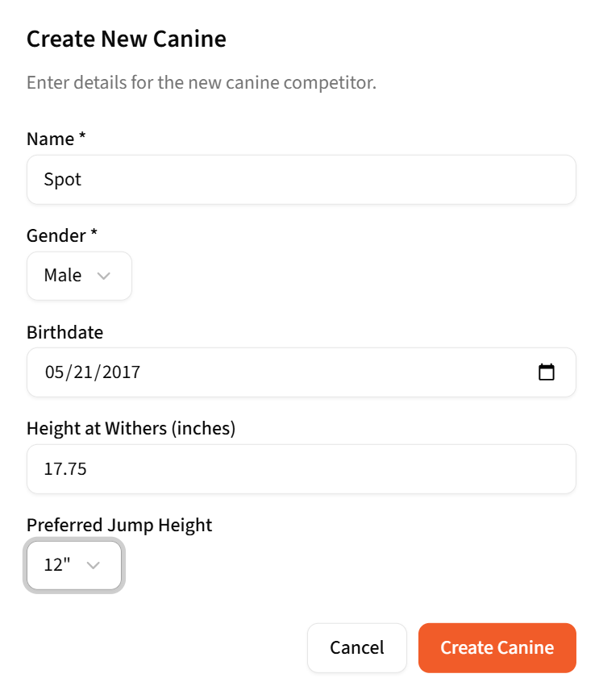

Give your team a name! The system will default to your name and the dog’s name, but you can name the team something different. Be creative and have fun with it! Once that is done add a fun fact. This will show up at the bottom of any system generated scoresheets and may be announced by the head judge. Click Next.
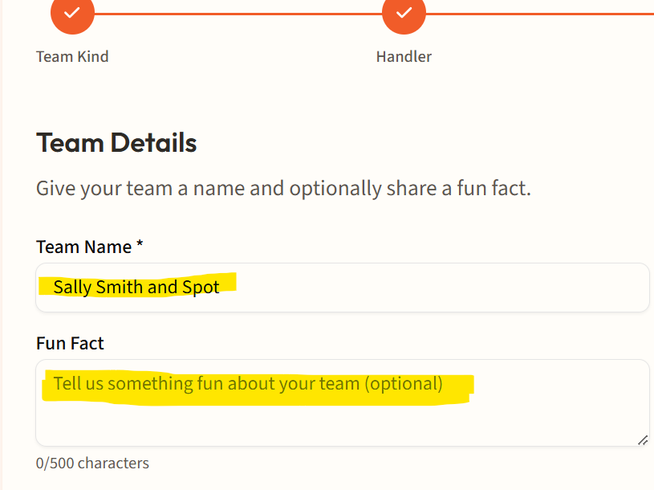 OR 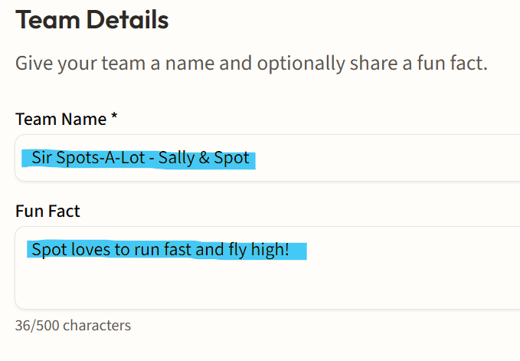
Review your team. If all looks good then click Create Team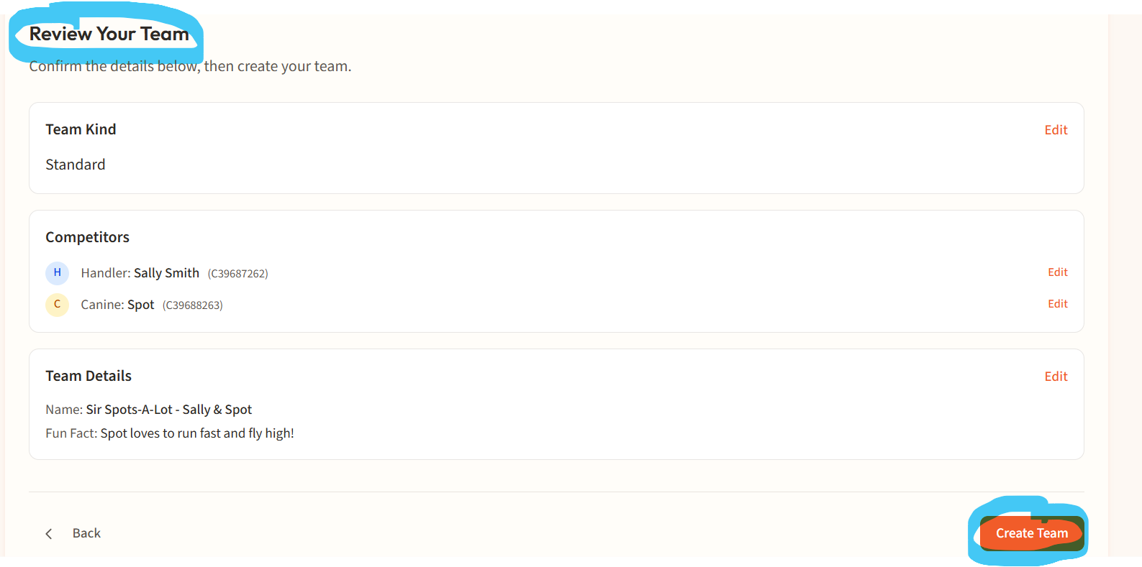

Step 3: Activate Your Team
Activating your team is optional but doing so allows you to earn Achievements and UPs and earn points towards qualifying for UPDIF.
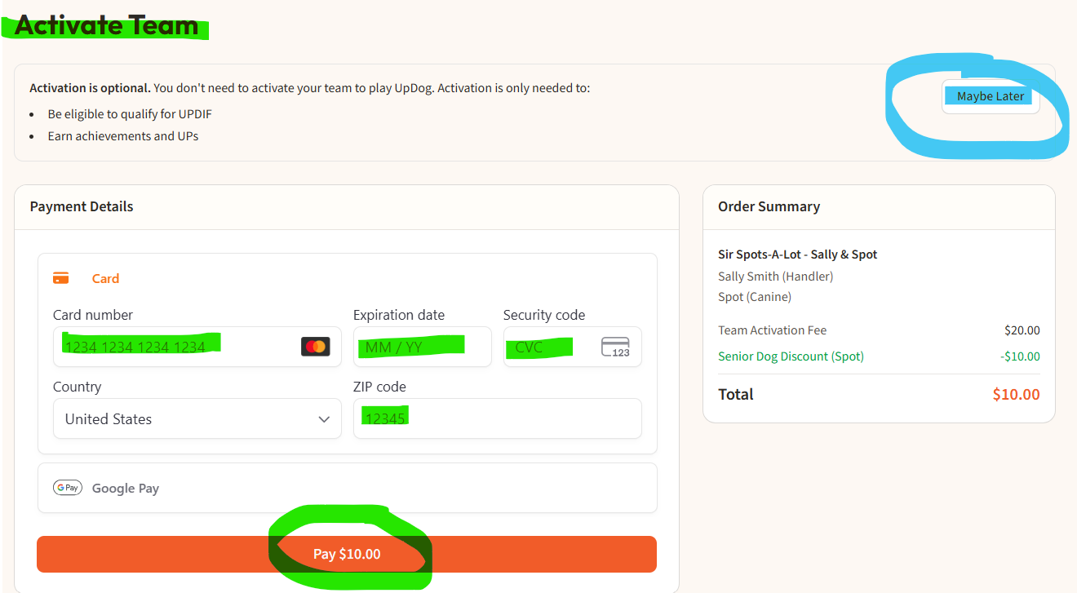

That is it – your team is created. Your team number is in the upper left. If you click the icon highlighted in green your team number will copy so you can paste it into a registration form, etc.
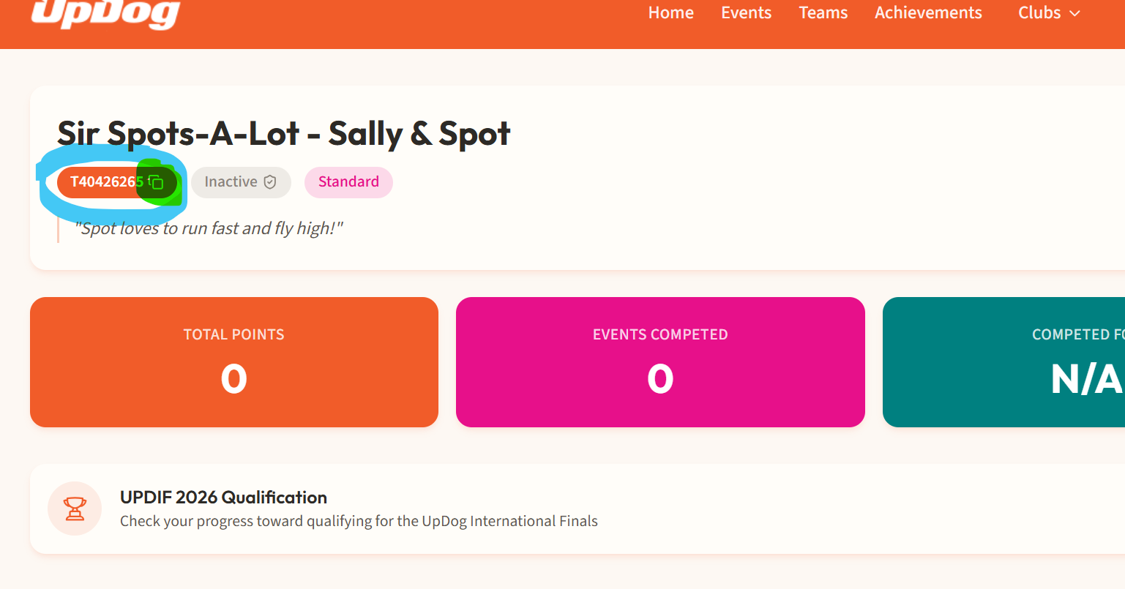
Congrats on your new team – go out and have an amazing time playing UpDog!!
If you have played UpDog with this dog prior to creating your team, email help@updogchallenge.com with your name, the dog’s name and your new Team Number and ask us to move your points from your temporary team to your new permanent team.

