
*****UpDog Triple Crown September 2024*****
Humboldt Disc Dog Trial Entry Form - 2 day Trial
- Date: September 7-8, 2024 – Saturday, Sunday
- Time: 9:00 – 4:00
- Location: Bartow Field, Rohner Park, Fortuna CA 95540
- Show Secretary: Roxanne Levang, rlvang7@gmail.com, 707-502-4231
- Limit 100 entries per trial. One page per dog.
-Entries close: Must be postmarked by August 30, 2024. Additional runs may be added day-of for dogs already entered - Judges: Beverly Chang, Kim Gradin, Debra Lake
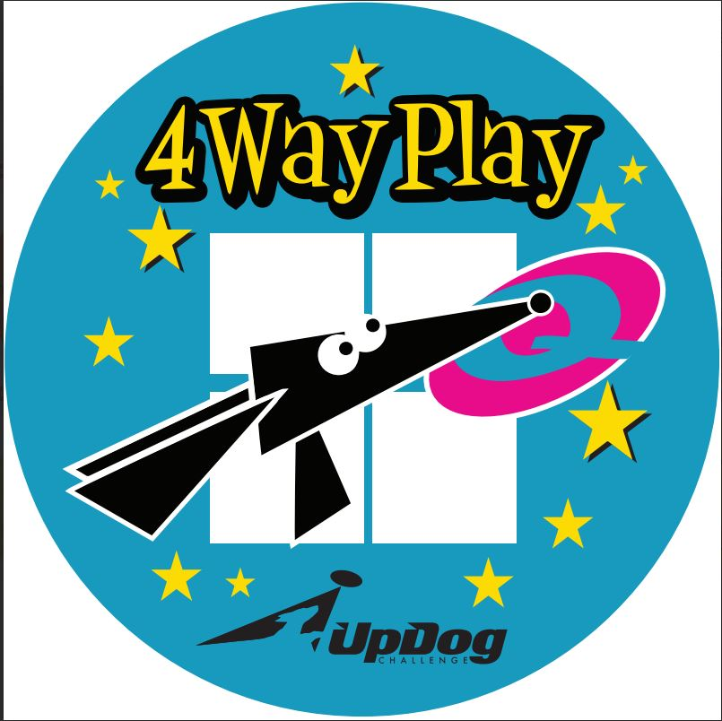
BIS may play wearing panties.
**Handler Information – Junior/PeeWee (yes) Age: ___ or (no)
- Name: ________________________________
- Junior/PeeWee’s Adult Signature __________________________
- Address: ______________________________
- Phone: _______________________________ **REQUIRED UPDOG INFO:
- Email: ________________________________ **TEAM NUMBER:
**Dog Information T-________________________
- Dog's Call Name: _________________________
- Breed: __________________________________ ENTRIES CLOSE BY POSTMARK AUGUST 30, 2024
- Date of Birth (approx. is not known): _______________________
- Jump Height (circle-applies to the whole trial): 4” 8” 12” 16” 20” 24”

**Trial Class Entry-$10 per class. Junior/PeeWee (Under 18 on trial date)-No entry fee
Please check the class(es) you wish to enter:

Saturday September 7, 2024 – order of games as required by UpDog Triple Crown
[ ] 4-Way Play-Round 1 [ ] 4-Way Play-Round 2 [ ] 4-Way Play-Round 3
[ ] Greedy-Round 1 [ ] Greedy-Round 2 [ ] Greedy-Round 3
[ ] Time Warp-Round 1 [ ] Time Warp-Round 2 [ ] Time Warp-Round 3

Sunday September 8, 2024
[ ] 4-Way Play-Round 1 [ ] 4-Way Play-Round 2 [ ] 4-Way Play-Round 3
[ ] Greedy-Round 1 [ ] Greedy-Round 2 [ ] Greedy-Round 3
[ ] Time Warp-Round 1 [ ] Time Warp-Round 2 [ ] Time Warp-Round 3
Total Rounds: _____X $10=___________
Additional Information
[ ] I would like to volunteer during the event.

[ ] I am a first-time competitor.
[ ] Member* (circle) Yes No *($10 Annual membership required for insurance purposes)

Waiver and Release of Liability
I understand that participating in a disc dog trial is a potentially dangerous activity and involves the risk of injury. I hereby waive and release any and all rights and claims for damages against the event organizers, sponsors, property owners, and all other parties involved in this event.

Signature: ______________________________________
Date: ______________________________

Please submit this form with the entry fee to Humboldt Disc Dogs c/o Roxanne Levang, 2356 Arbutus St., Eureka CA 95503
For Office Use Only
______ CASH $_______ _______Membership application, if needed

______ CHECK #______ Show Secretary Initials: _______

