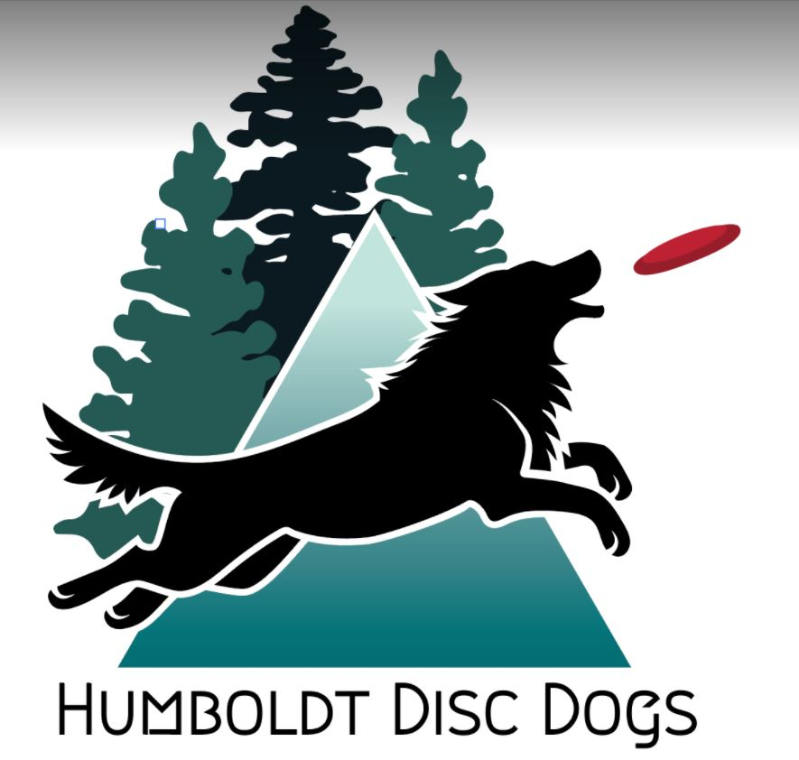
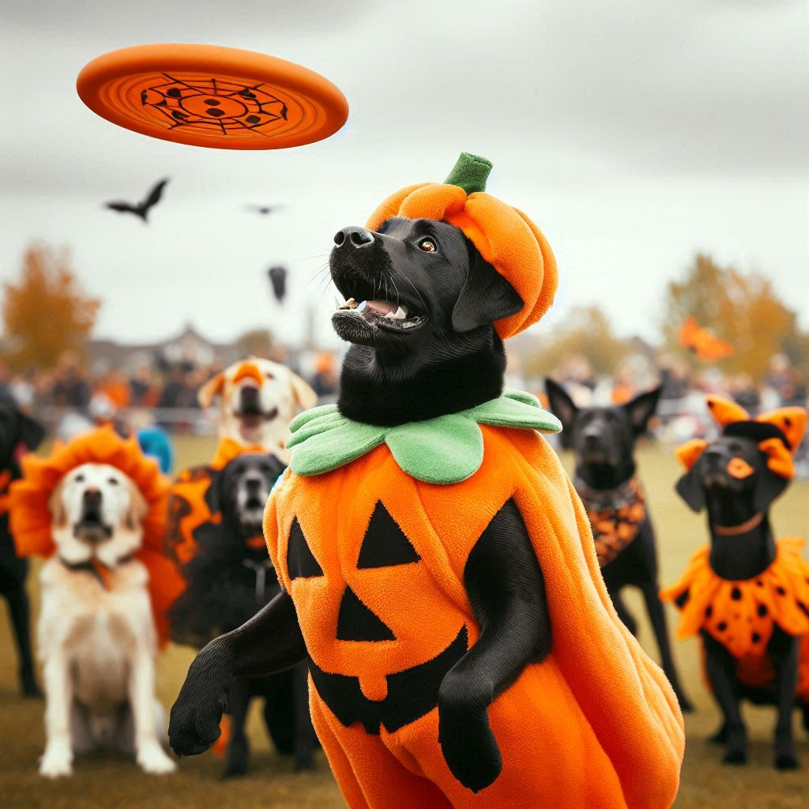
Humboldt Disc Dog Monster Mash Trial
Family Friendly Costumes Encouraged (But not required)
Humboldt Disc Dog Trial Entry Form - One day Trial
- Date: October 5, 2024 – Saturday
- Time: 9:00 – 4:00
- Location: Bartow Field, Rohner Park, Fortuna CA 95540

- Show Secretary: Roxanne Levang, rlevang7@gmail.com, 707-502-4231
- Limit 130 entries per trial. One page per dog.
-Entries close: Must be postmarked by September 25, 2024. Additional runs may be added day-of for dogs entered if entries are available - Judges: Beverly Chang, Kim Gradin, Debra Lake and Sasha Essig
ENTRIES CLOSE September 25, 2024 (postmarked). BIS may play wearing panties.

**Handler Information – ( ) Adult ( ) Junior-12-under 18 ( )Peewee-under 12 at trial date- Age: ___
- Name: ________________________________________
- Junior/PeeWee’s Adult Signature __________________________
- Address: ______________________________________________
- Phone: _________________________________ **REQUIRED UPDOG INFO:
- Email: ________________________________
**TEAM NUMBER:
**Dog Information T-________________________
- Dog's Call Name: _________________________
- Breed: __________________________________
- Date of Birth (approx. is not known): ________________
- Jump Height (for Hybrid games-applies to the whole trial): 4” 8” 12” 16” 20” 24”

**Trial Class Entry-$10 per game. Junior/Peewee (Under 18 on trial date) and Freestyle Performance-No entry fee

Please check the game(s) you wish to enter:
Saturday October 5, 2024
4-Way Play- [ ] Round 1 [ ] Round 2 [ ] Round 3
Throw N Go- [ ] Round 1 [ ] Round 2 [ ] Round 3
Frizgility [ ] Round 1 [ ] Round 2 [ ] Round 3 Total Rounds: _____X $10=___________
*********************************************************************************
( ) Freestyle Performance Exhibition Only, Beginner Level-To be held after the three games. Suggest Halloween music.
***************************************************************************
Awards: High in Trial-Custom logo cutting board. Highest accumulated high score of 3 games played utilizing highest score by game type per Team. (Donated by Monument Mountain Miniature American Shepherds)
Rosettes-First, Second and Third place per game. (Custom made)
Candy for Junior/PeeWee Entrants.

Additional Information
[ ] My dog needs the field clear of dogs. A * will be put by your dog’s call name on the running order to facilitate clearing the field.
[ ] I would like to volunteer during the event.
[ ] I am a first-time competitor.
[ ] Member* (circle) Yes No *($10 Annual membership required for insurance purposes)
Waiver and Release of Liability
I understand that participating in a disc dog trial is a potentially dangerous activity and involves the risk of injury. I hereby waive and release any and all rights and claims for damages against the event organizers, sponsors, property owners, and all other parties involved in this event.
Signature: ______________________________________
Date: ______________________________
Please submit this form with the entry payment to Humboldt Disc Dogs c/o Roxanne Levang, 2356 Arbutus St., Eureka CA 95503
For Office Use Only
______ CASH $_______ _______Membership application, if needed
______ CHECK #______ Show Secretary Initials: _______

