
Humboldt Disc Dog Trial Entry Form
- Date: May 12, 2024 – Sunday
- Time: 9:00 – 4:00
- Location: Bartow Field, Rohner Park, Fortuna CA 95540
- info @ Beverly Chang-show secretary-707-764-3143

**Handler Information
- Name: _______________________ **REQUIRED UPDOG INFO:
- Address: _______________________ **TEAM NUMBER ________________
- Phone: _______________________ **TEAM NAME ___________________
- Email: _______________________


**Dog Information
- Dog's Call Name: _______________________
- Breed: _______________________
- Age: _______________________
- Jump Height ___4”____8”____12”____16”___20”___24”

**Trial Class Entry-$10 per class
Please check the class(es) you wish to enter:
[ ] Throw N Go Round 1 [ ] Throw N Go Round 2 [ ] Throw N Go Round 3
[ ] 4 Way Play Round 1 [ ] 4 Way Play Round 2 [ ] 4 Way Play Round 3
[ ] Frizgility Round 1 [ ] Frizgility Round 3 [ ] Frizgility Round 3
Total Rounds X $10=___________

Additional Information
[ ] I would like to volunteer during the event.
[ ] I am a first-time competitor.
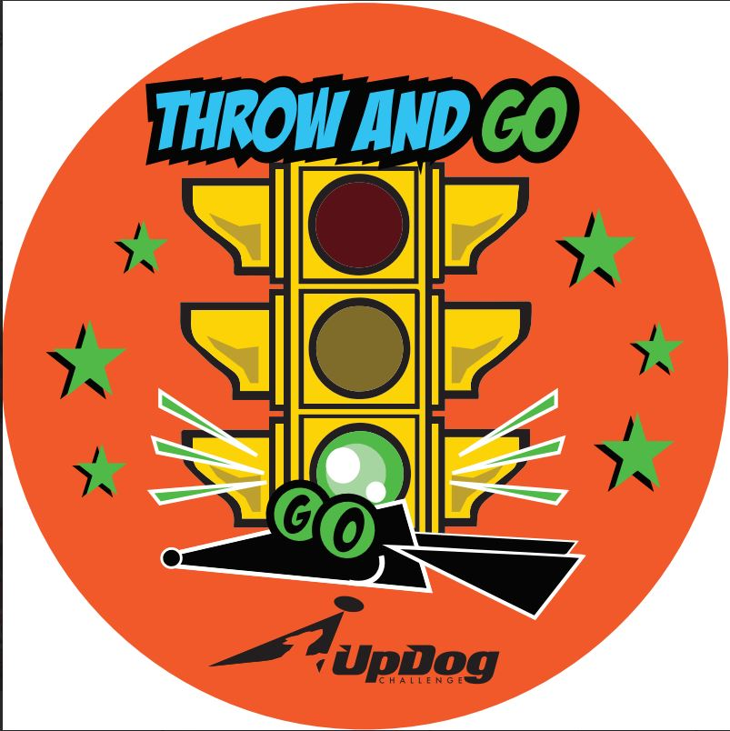
[ ] Member [ ] Yes [ ] No ($10 Annual membership required (due to insurance requirements))

Waiver and Release of Liability
I understand that participating in a disc dog trial is a potentially dangerous activity and involves the risk of injury. I hereby waive and release any and all rights and claims for damages against the event organizers, sponsors, property owners, and all other parties involved in this event.

Signature: _______________________
Date: _______________________
Please submit this form with the entry fee to Humboldt Disc Dogs c/o PO Box 105, Rio Dell, CA 95562

For Office Use Only
______ CASH $_______ _______Membership application, if needed

______ CHECK #______

Show Secretary Initials: _______

