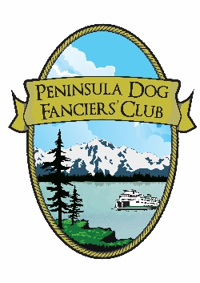
Peninsula Dog Fanciers’ Club

Announces our 2nd Annual

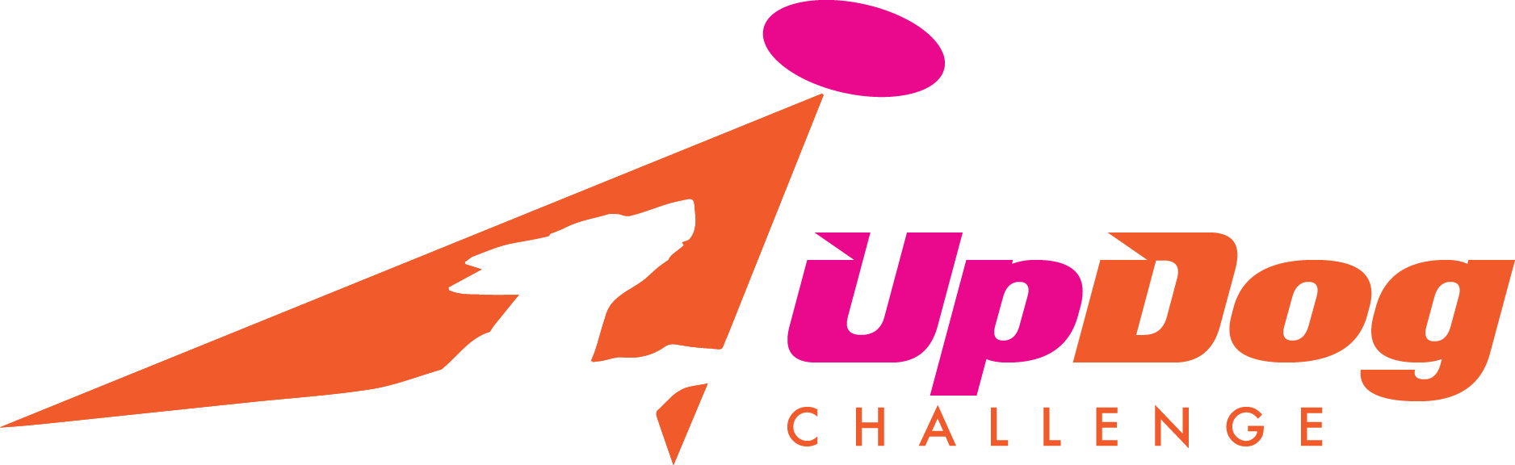
Spring Fling
KITSAP COUNTY FAIRGROUNDS
Concert Park
1200 Fairgrounds RD NW, Bremerton WA 98311
Outdoors on grass/ Fenced Playing Field

Games:
4 Way Play, 4 Way Play Teams, Greedy, Free Style, Frizgility,
Time Warp, Spaced Out, Throw-N-Go
Entries Open March 22, 2023 at 6 PM Pacific Time
See the link
https://form.jotform.com/230554252411142

or Peninsula Dog Fanciers Website for entry forms

<https:// peninsuladogfanciers.org/updog-challenge/>

Any questions contact April Caron @robyntuttle@msn.com
Or Diane Burlingame @ blueskytollers@gmail.com

This event will follow the rules and regulations of UpDog Challenge
For more information about UpDog Games and their Rules go to https://updogchallenge.com

Event supported by: Kitsap Fair & Stampede Association

