Go to teams.updogchallenge.com
Click on Join
UpDog
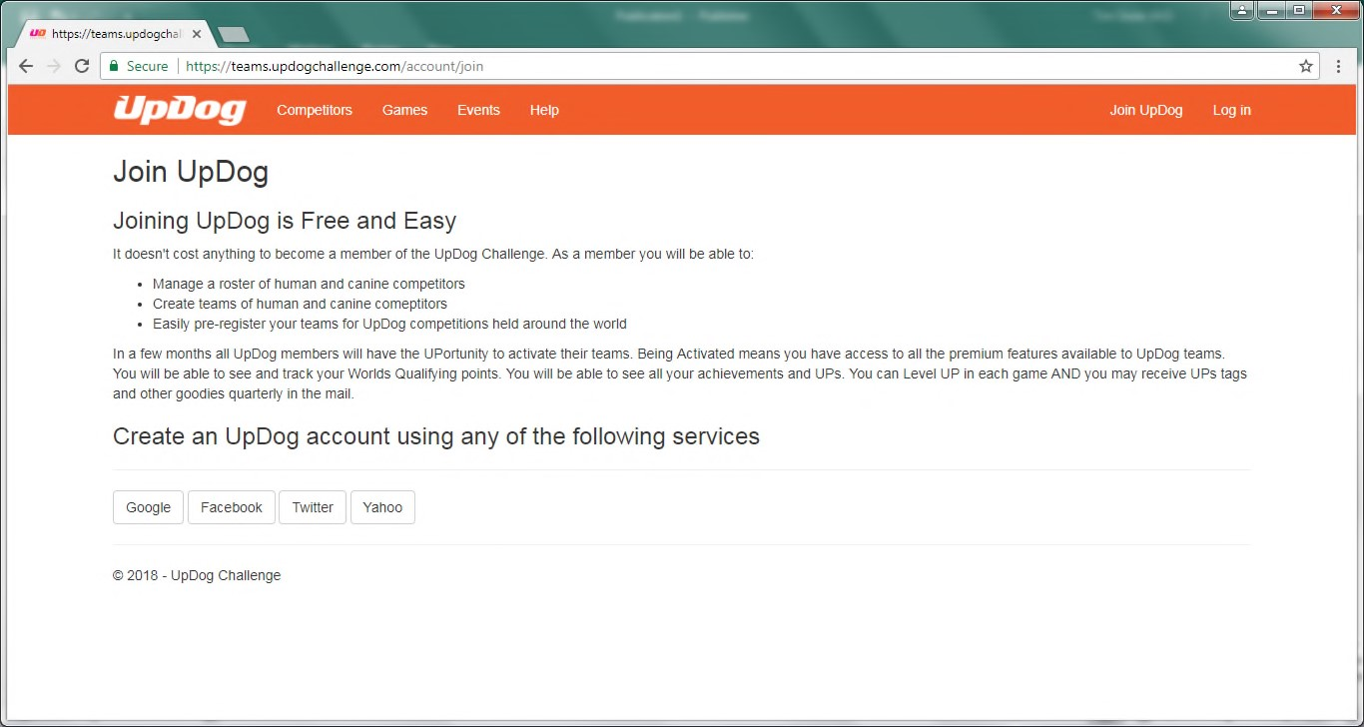
Create an account using
one of these profiles
After creating a pro-
file, log in here
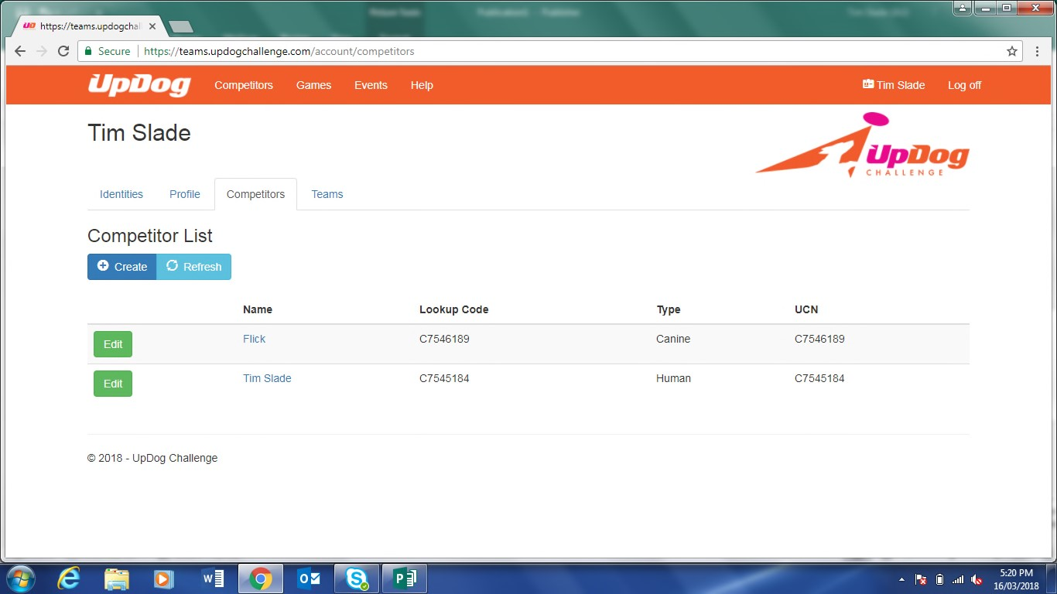
Now add competitors and dogs:
Click the Competitors tab
Click Create to add
people and dogs

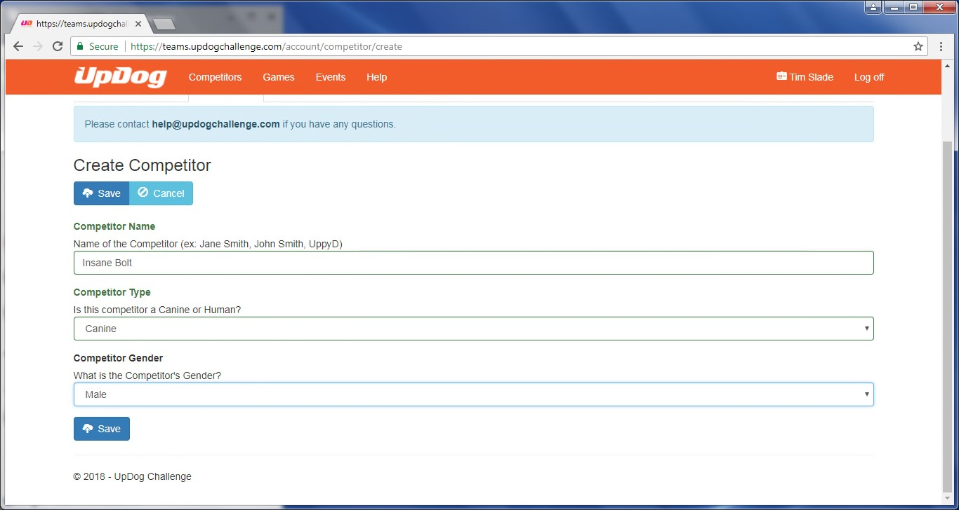
Fill in details
and hit save

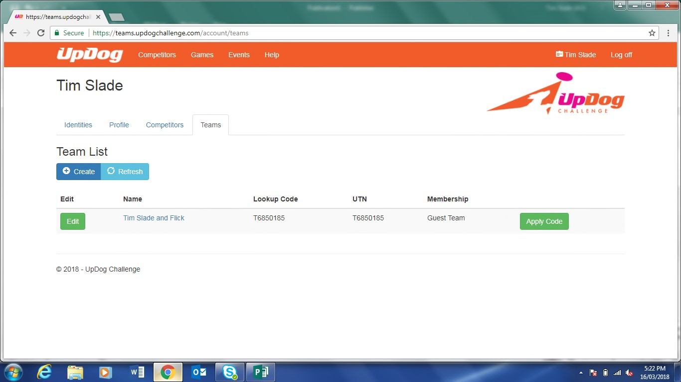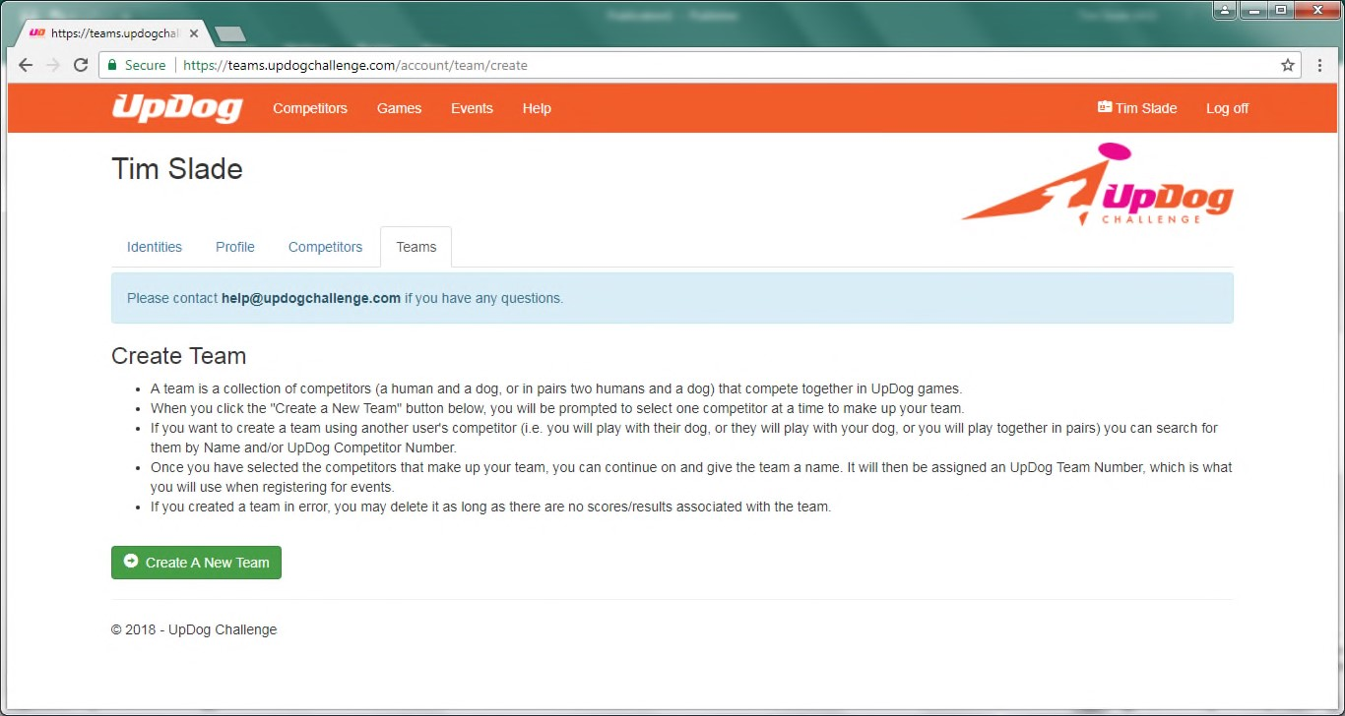
Now click on
teams tab
Click create
Click Create A
New Team

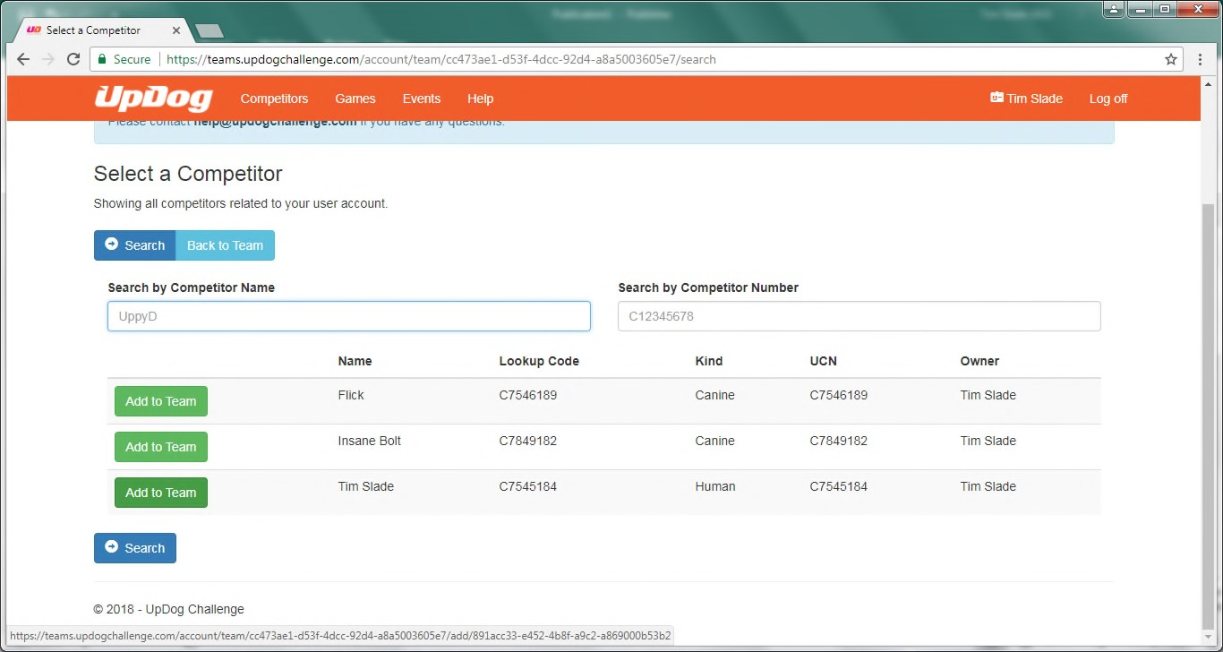
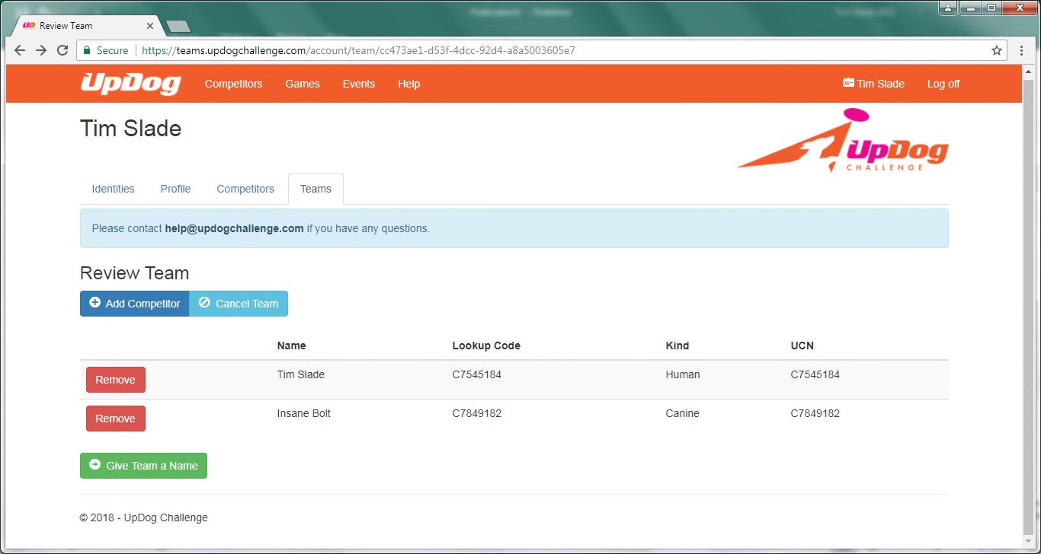
Choose a human or dog and click Add to Team
Click Add Competitor
Select the 2nd team member and click Add To Team
Click give team name, can
use default or make one up

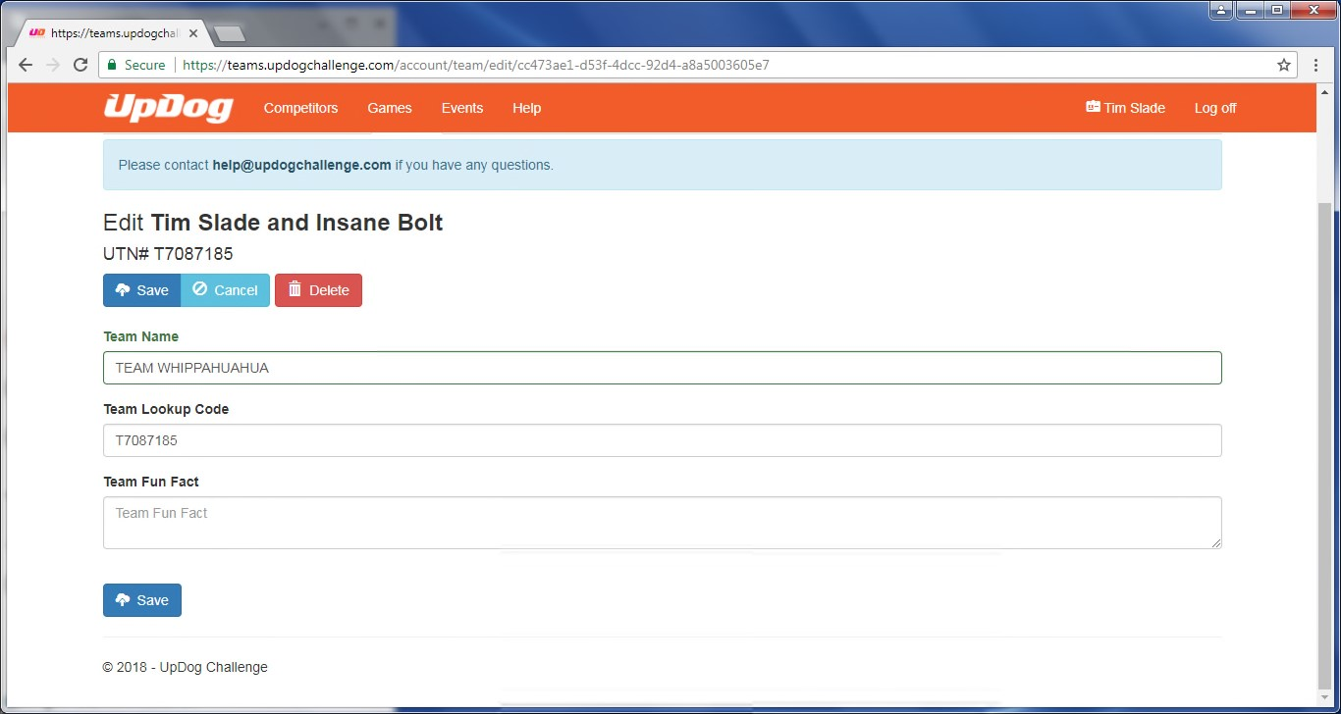
Press Save when
complete
Team Name
Team Code used on
comp entries
To Activate a Team:
Login to the team site and review your list of teams. Click the “Activate” button.
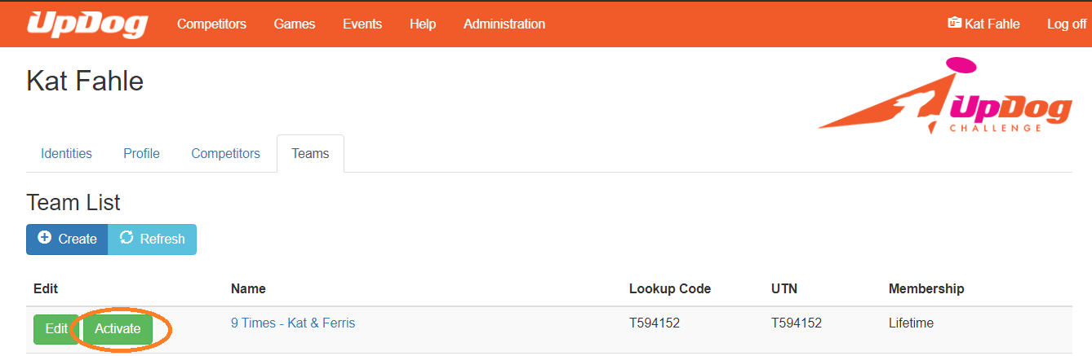

Review your information and make any changes necessary. Click Create Activation Order & Checkout.
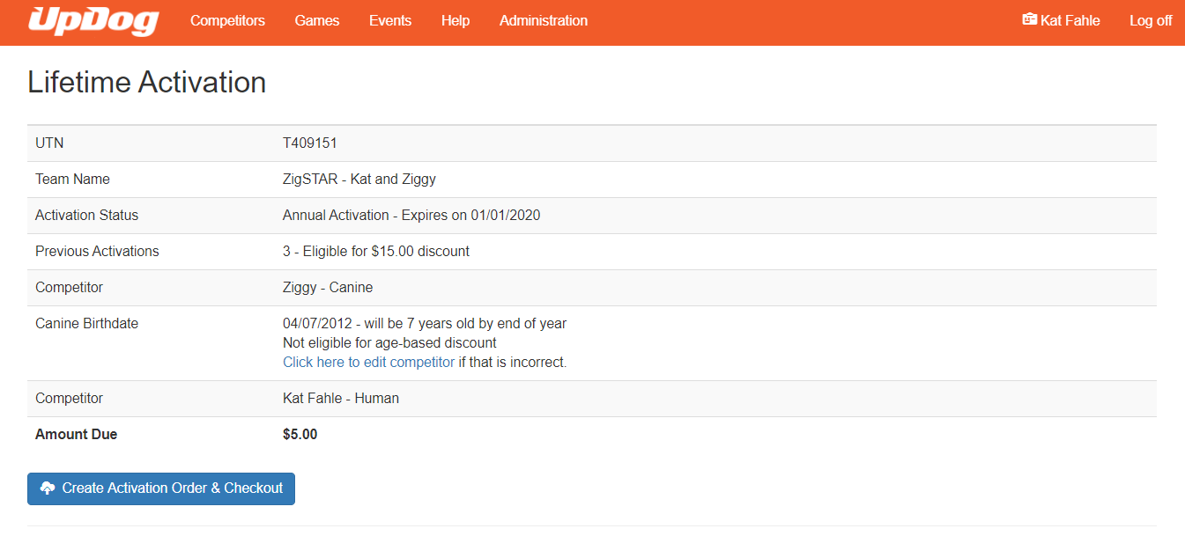
Review your information and click Pay with Credit Card.
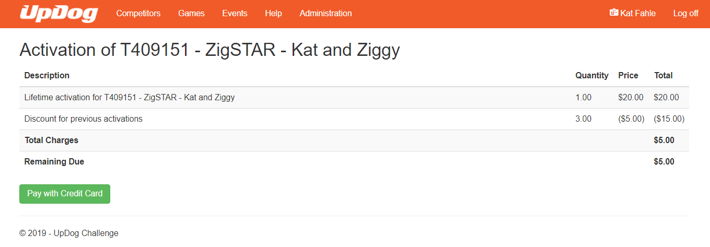
Enter your credit card information.
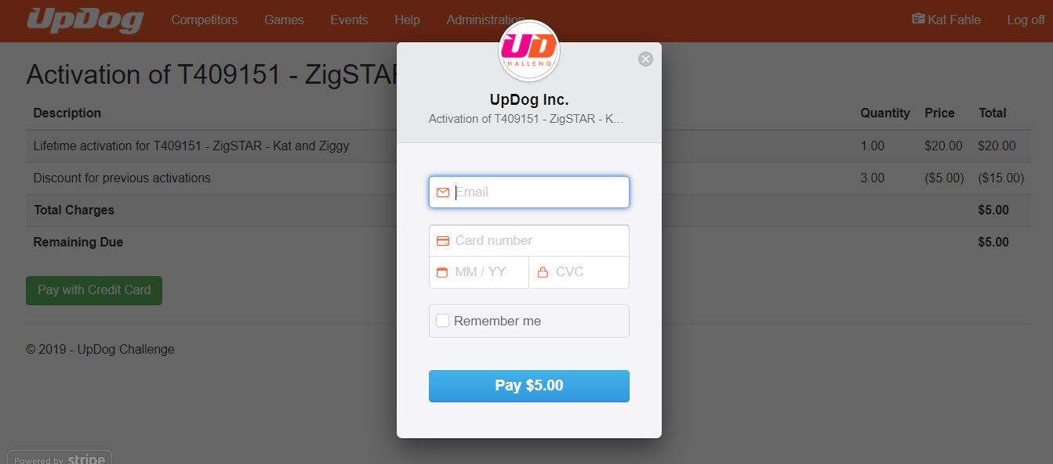

Once paid, your team status will show like the one below. This team now has a lifetime activation and will not need to be activated again going forward.
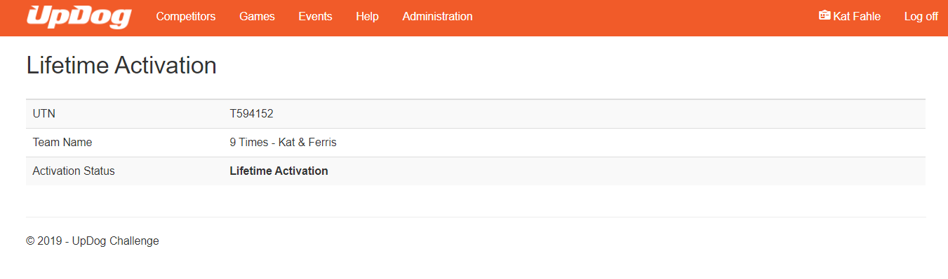If you have played UpDog prior to activating your team email Help@updogchallenge.com to have your data moved to your permanent team. Include your name, dog name and either your team name or team number. Your team number is found on the login page under the column “UTN” and will show an expiration date to the right. This is the number to provide to host clubs when registering as well.

Happy UpDogging!

