If your dog loves to play fetch and/or agility, then UpDog is for you!! ALL

skill levels are welcome!

**WHERE: 5030 Lake Griffin Road**

***FULLY FENCED FIELD for Safety!!***

**Lady Lake, FL 32159**

**WHEN: Saturday, December 22, 2018**

**START TIME: 8:00 AM**

**DISCOUNTS FOR Pre ENTRY postmarked by: Dec. 12, 2018**

**COST:** Registration and payment postmarked by December 12, 2018 $12 per run / $55 all five runs same dog

Day of Show (if available) $15 per run

Send registration forms and checks payable to NorAust:

NorAust 5030 Lake Griffin Road, Lady Lake, FL 32159

Limited RV electric hook ups 30 AMP $35/night

Dry Camping $12.50/night

**RV reservations please email in advance to reserve**

**Questions or RV reservations:** noraustkennel@gate.net

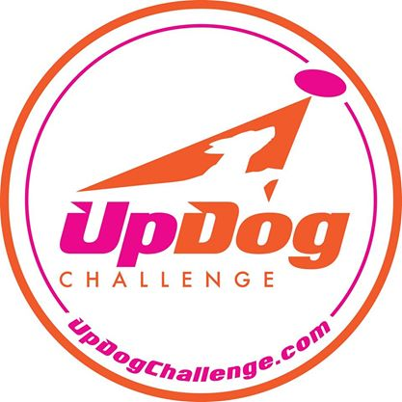

**Visit our Christmas Photo Booth!**

|  |  |  |  |  |  |  |
| --- | --- | --- | --- | --- | --- | --- |
| **UpDog Entry**  Hosted by **NorAust** | | | | | | |
| **Show Date: Saturday, December 22, 2018** | | | | | **Pre Entry Closing Date: December 12, 2018** | |
| Entry Method: First Received, No opening date | | | | | | |
| Make entry fees payable in US funds to: **NorAust** | | | | | | |
| Mail Entries to: NorAust 5030 Lake Griffin Road Lady Lake, FL 32159 | | | | | | |
| UpDog Team # | | | Dog’s Call Name | | | |
| Breed | | | | | | |
| Date of Birth | | | | | | Sex: M F |
| Jump Height: | | 4 8 12 16 20 24 | | | | |
| Circle Height Division:  (ONLY ONE)  **Mini Midi**  **Maxi Mega** | | Height Division Options | | | | |
| Mini | | | | 13” or less at shoulder jumps 4,8,12,16 |
| Midi | | | | 13-17” at shoulder jumps 8,12,16,20 |
| Maxi | | | | 17-12” at shoulder jumps 12,16,20,24 |
| Mega | | | | Over 23” at shoulder jumps 12,16,20, 24 |
| Owner | | | | | | |
| Handler (if different than owner) | | | | | | |
| Address | | | | | | |
| City / State / Zip | | | | | | |
| Phone & email | | | | | | |
| **Both Level 1 and Level 2 will be offered. Please check to ensure your team is eligible for Level 2.** | | | | **Pre Registration $12 per run**  **All five runs same dog $55**  **Day of Show or after 12/12/18 $15 per Run** | | |
| Fun Key | 1 2 | | |  | | |
| Frizgility | 1 2 | | |  | | |
| 4 Way Play | 1 2 | | |  | | |
| Throw and Go | 1 2 | | |  | | |
| Time Warp | 1 2 | | | **Total Enclosed:** | | |

Upon acceptance of this entry, I / we agree to hold NorAust, LLC, the owner or lessee of the premises, any sponsors of this event, and each of their members, directors, officers, agents, show secretary, show chairperson, and employees harmless from any claim or loss or injury or expenses (including attorney fees) which may be alleged to have been caused directly or indirectly to any person or thing arising out of or in consequence of my / our participation in the Event; or the act of my/our dog, howsoever such injuries or damage may be caused and whether or not the same may have been caused by negligence of the aforementioned parties or any of their employees or agents, or any other persons. I / we further agree to hold the aforementioned parties harmless from any claim or loss of this dog by disappearance, theft, death or otherwise, and from any claim for damage or injury to the dog, whether any claim be caused or alleged to be caused by the negligence of the Host Club or any of the parties aforementioned, or by the negligence of any other person, or any other cause or causes.

|  |
| --- |
| **THIS DISCLAIMER MUST BE SIGNEDAND INCLUDED FOR A VALID ENTRY** |
| **I / we agree to abide by the rules and all terms and conditions pertaining to this Event. I/we testify that the dog entered is healthy and vaccinated or titered. I/we certify that the dog entered is not dangerous to any person or other dog. By signing below, I/we agree to the disclaimer and indemnity obligations on this entry form.**  Signature – Owner or Parent / Guardian if Minor Date |